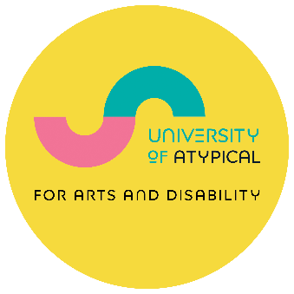

Atypical Generation Fund

2026-2027

Application Form

These awards are funded by:
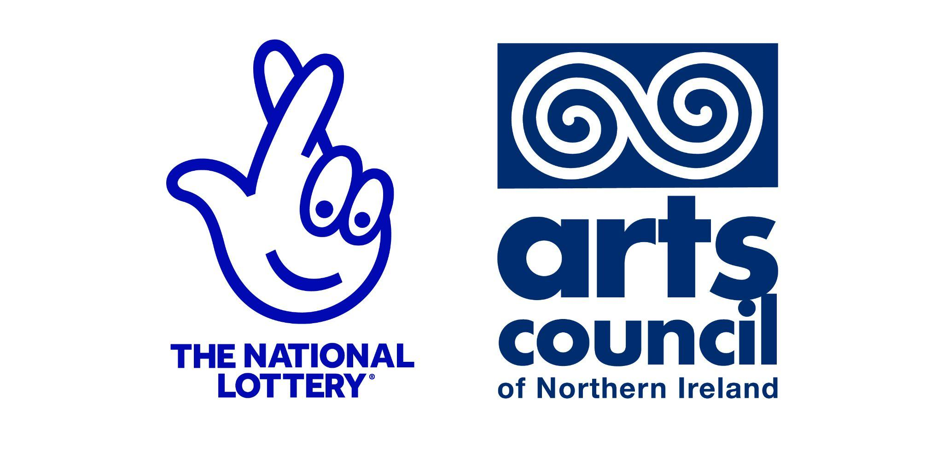
University of Atypical for Arts and Disability is core funded by:
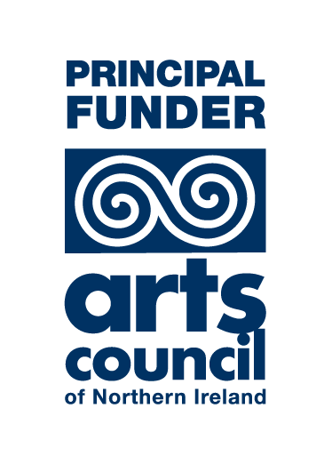 | 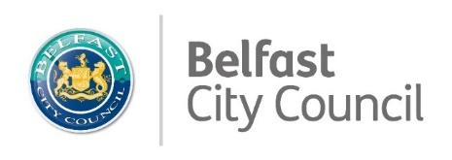
Important information about submitting your application:
We have a dedicated email address to submit your application:
- Email your completed application, with all required materials, to: applyto@universityofatypical.org
- Put ‘Atypical Generation Application 2026’ in the subject line of your email.
- Attach examples of your work (details in Section 7).
- Your application must be submitted by Tuesday 10 March 2026 at 4:00 pm

Application Support:
Alternative Formats
If you need this application in a different format, contact us at jonathan@universityatypical.org at least two weeks before the deadline.
Guidance Notes
Please read the Guidance Notes carefully before you start, and refer to these as you fill in the form. These explain what we want, and why.
Advice Sessions
You can request a session in several ways:
- You can email jonathan@universityofatypical.org
- You can phone us at 028 9023 9450.
- You can use the online booking form.

Atypical Generation Fund - Key Information and Dates
- Application opens: Monday 2 February 2026 at 12:00 pm
- In-person advice session at the Ledger Studio in University of Atypical: Tuesday 17 February 2026 at 2:30 to 4:00 pm
- Online advice session: Thursday 19 February 2026 at 6:00 to 7:00 pm
- One-to-one advice sessions open: Tuesday 3 February 2026 to Thursday 5 March 2026. You can book a time that suits you.
- Application closes: Tuesday 10 March 2026 at 4:00 pm*
- Announcement of successful applications: April 2026
- Evaluation and reports submitted: 11 December 2026

*You must submit your completed application form with budget, monitoring form, and supporting material by this deadline.

Section 1: About You (see Section 1 of Guidance Notes)

Your name:

First Name:

Surname:

Pronouns:

Your Address:

Street Address:
City/Town: | Postcode:
Your contact information:  Home Phone: | Mobile:
Email: | Website:

Section 2: Art Form (see Section 2 of Guidance Notes)
- Place an X beside the art form that best describes your practice that is relevant to your application.
- Add specific details in the ‘additional information’ section.
- For example, if you write poetry, tick Literature, then write ‘Poetry’ in the space provided. If you write lyrics, tick Music and then write ‘Lyrics’ in the space provided.

Art form:

Music (including Traditional)
Visual Arts / Craft (including Photography)
Literature / Language Arts
Comedic Arts
Dance
Film-based Visual Art / Digital Art (including Animation)
Drama / Theatre
Circus / Carnival
Performance Art
Combined Arts / Interdisciplinary
Other Art Form

Additional Information (maximum 100 words)

Section 3: d/Deaf, Disabled and Neurodivergent (see Section 3 of Guidance Notes)

Eligibility
You must self-declare as D/deaf, disabled, or neurodivergent to be eligible to apply.
Do you self-declare as d/Deaf, disabled or neurodivergent? (delete as appropriate): Yes/No

Disability
Place an X in the main disability categories that apply to you:

Mobility or physical impairment
d/Deaf, hearing impairment, hearing aid-user
Blind, partially sighted or visual disability
Mental ill health / mental health difficulty
Learning difficulty
- Examples include dyslexia, dyspraxia or dysgraphia or other
Learning disability
- A learning disability is a reduced intellectual ability, usually identified soon after birth or in the early years, and will last a person’s whole life.
Neurodivergent
Hidden disability (for example, epilepsy, diabetes, acquired brain injury)
Other (please state)

If you would like to give more information, use the space below (Maximum 100 words).

c) Please tell us if your d/Deafness, disability, and/or neurodiversity impacts or informs your creative practice. This impact may be positive or negative. (Maximum 250 words)

Section 4: Background Information (see Section 4 of Guidance Notes)
- Tell us about: your arts-related experience, qualifications, awards, exhibitions, or performances. (Maximum 300 words)
- Do not add extra sheets or a C.V.

Section 5: Your Proposal (See section 5 of Guidance Notes)

a) Your idea or project (see 5a of Guidance Notes)
- Tell us about your proposal.
- How does your application meet the four grant criteria?
- Tell us what you want to achieve. For example: upskilling, new learning, networking, research, mentoring, purchasing materials, hiring space, production of work.
Your proposal (Maximum 500 words)

b) Timing and delivery (see 5b of Guidance Notes)
- What is the start date of your project proposal?
- What are the key milestones or targets for delivering your proposal?
- What is the finish date for the proposal?
Timing and Delivery (Maximum 100 words)
Date | Key activity
- The Atypical Generation Fund projects must be completed by Friday 11 December 2026.

Section 6: Project Costs and Income (see Section 6 of Guidance Notes)
- Please attach a budget for your proposal. This should include all the costs of your project and show how the fund you are applying for will be spent.
- You can get a budget template from our website. You can also get one by emailing applyto@universityofatypical.org
- Please ensure you check Section 6 of the Guidance Notes for eligible costs.

Section 7: Support Material (see Section 7 of Guidance Notes)

a) Support material
- You must include support material. The decision panel uses the support material when they assess your application and make their decision.
- Select examples of work that you think best represent your creative practice. Follow the Guidance Notes for your art form.
- You can submit a link to a website, but you must ensure that it works. University of Atypical does not accept responsibility if we cannot access the web link. Please refer to the Guidance Notes for more information.
- You must submit support material in a format that the panel can access (see Guidance Notes for formats).
- You can email support materials as individual files or links, or embed these in a pdf document.

List your support material
Support Material 1
Support Material 2
Support Material 3

Please tick below to tell us the type/s of support materials you are submitting:

- CD
- DVD
- Manuscript
- Image files
- Publication
- Review
- Script
- Video file
- Audio file
- Weblink
- Other (please give details)

Section 8: Declaration (see Section 8 of Guidance Notes)
- We accept electronic signatures with online applications.
- If you are submitting a paper application, you must sign this sheet and return it to us.

a) Applicant declaration
I declare the following:
- All information in this application is truthful and accurate, and all material submitted in support of this application has been created by me.
- I am d/Deaf, disabled, or neurodivergent.
- I am aged 18 years or older.
- I have a UK bank account in my own name which a successful award could be paid into.
- I did not receive a D/deaf and Disabled Artists Support Fund in 2025-26.
- I am not a full-time student (that is, studying more than 20 hours per week for a qualification).
- If I am a Masters or PhD student, I have included a separate statement showing how my application project differs from my Masters or PhD work.
- I have been a permanent resident in Northern Ireland for more than 12 months.
- I have read the Guidance Notes documents. I understand that I need to inform University of Atypical at once if there is any change in my circumstances.

Applicant signature:

Name in capitals:

Date:

b) Advocate or support worker declaration:
- I am a parent / friend / care worker / interpreter of the applicant (underline as applicable).
- I have completed and/or signed the application on the applicant’s behalf for accessibility reasons.
- I declare that this application has been completed with the full knowledge of the applicant, and that I am signing to confirm the applicant’s compliance with the declaration above.
- I will not obtain financial benefit from the applicant’s grant.

Applicant signature:

Name in capitals:

Date:

Address and postcode:

Telephone:

Email

Section 9: Checklist (see Section 9 of Guidance Notes)
Please tick to confirm that you have uploaded or included the following essential components:
Completed application form
Budget breakdown
Support material
Monitoring form
Signed declaration (by you or your advocate)
If any part of the application is in an alternative format (for example, audio,
Braille, or British Sign Language video), tell us about this below. Tell us which
sections are supplied in this format.
Accessible Formats (Maximum 100 words)

Submitting by Email
- Email your completed application, with all required materials, to applyto@universityofatypical.org with ‘Atypical Generation Application 2026’ in the subject line.
- You will receive email confirmation that we have received your application within 3 working days.
- You should submit your support material and monitoring form at the same time as your application.
- If your application or support material does not arrive on time, your application will be ineligible.
- It is the applicant’s responsibility to ensure that deadlines are met.
- University of Atypical cannot extend deadlines. We do not accept any liability for technical failure or undelivered mail.
- Please keep a copy of your application for your own records.

Submitting a Paper Copy
- You will receive email confirmation that we have received your application within 3 working days from receipt.
- To submit a paper copy application you can:
  - Email a photocopy to: applyto@universityofatypical.org
  - Hand deliver or post to: University of Atypical, 109–113 Royal Avenue, Belfast, BT1 1FF. Write ‘Atypical Generation Application 2026’ on the envelope.
- Support material must arrive at the same time as your application form.
- If support material does not arrive on time, the application will be ineligible.
- You must submit a signed hard copy version of the declaration in Section 8.

Please keep a copy of this application for your own records.
Good luck with your application!

