Atypical Generation Fund 2026-2027
Supported by the National Lottery through the Arts Council of Northern Ireland

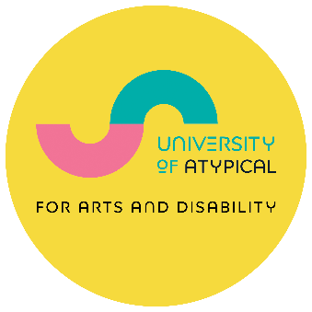

Guidance Notes

We have a dedicated email address to submit your application to:
- Email your completed application, with all required materials, to applyto@universityofatypical.org
- Put ‘Atypical Generation Application 2026’ in the subject line of your email.
- Attach examples of your work (details in Section 7).
- Your application must be submitted by the deadline: Tuesday 10 March 2026 at 4:00 pm.
- Completed application forms and supporting materials must be submitted by the deadline.

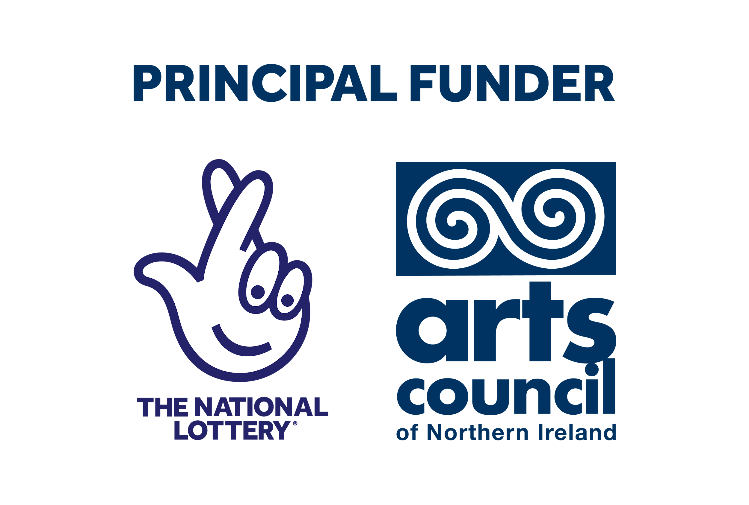 | 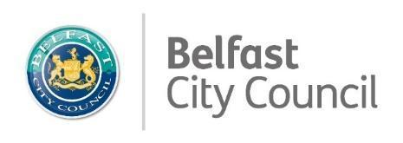

Atypical Generation Fund Key Information and Dates
- Application opens: Monday 2 February 2026 at 12:00 pm
- In-person Information session: Tuesday 17 February 2026 from 2:30 to 4:00 pm
- Online Information session: Thursday 19 February 2026 from 6:00 to 7:00 pm
- One-to-one advice sessions open: Tuesday 3 February 2026
- Final one-to-one advice sessions: Thursday 5 March 2026
- Application closes: Tuesday 10 March 2026 at 4:00 pm*
- Announcement of successful applications: April 2026
- Evaluation and reports submitted: 11 December 2026

*You must submit your completed application form with budget, monitoring form, and supporting material by this deadline.

Application Support:

Alternative Formats
If you need this application in a different format, contact us at jonathan@universityofatypical.org at least 2 weeks before the deadline.

Guidance Notes
Please read the Guidance Notes carefully before you start, and refer to these as you fill in the form. These explain what we want, and why.

Advice Sessions
You can request a session in several ways. You can email us at jonathan@universityofatypical.org . You can phone us at 028 9023 9450. You can use the online booking form.

About Advice Sessions

Information Session
- We will hold an information session in the Ledger Studio at University of Atypical on Tuesday 17 February 2026 from 2:00 - 4:00 pm. This will be a group event with a presentation. It will provide an opportunity to ask questions about the award scheme. It will not be streamed.
- There will also be an online session with the same information on Thursday 19 February 2026 from 6:00 - 7:00 pm.
- You do not need to attend to apply for an award. However, there have been changes to the award this year.
To book your place for the one of the information sessions:
- Fill in the booking form.
- Email us: administration@universityofatypical.org.
- Phone us: 028 9023 9450.

One-to-One Advice Sessions
- You can book a one-to-one advice session with a trained advisor in several ways:
- Fill in the booking form.
- Email us: jonathan@universityofatypical.org.
- Phone us: 028 9023 9450.
- Advisors can help you with the application form, to understand the criteria, and to check your proposed budget. They can proofread the application or ensure all aspects of the application are eligible.
- Advisors cannot comment on whether your application is likely to be successful or help you to develop your project idea.
- Let us know if you have any access requirements (for example, a British or Irish Sign Language interpreter).
- Our website has a video that explains how to complete the application form. The video has captions and a voiceover. It is available with Irish or British Sign Language.

Atypical Generation Fund 2026-2027
- This fund includes 20 awards of £1,000 each.
- All art forms will be considered.
- It is for artists to buy Creative Time or pay for a Creative Project.
- It is funded by the National Lottery through the Arts Council of Northern Ireland.

More Information About the Awards:
- You must be at least 18 years old.
- Full-time students cannot apply. However, Masters or PhD students may apply as long as you include a separate statement that describes how your application project differs from your Masters or PhD work.
- You must be ‘domiciled’ in Northern Ireland for tax purposes. This means you must have lived in Northern Ireland for a continuous period of 12 months prior to making the application.
- You must have a UK bank account in your own name.
- If you received a D/deaf and Disabled Artists Support Fund in 2025-26, you cannot apply for an Atypical Generation Fund 2026-2027.
- If you applied for a D/deaf and Disabled Artists Support Fund in 2025-26 or a Digital Innovation Award Fund 2025-26 and were unsuccessful, you can apply again.

Guidance Notes by Section

Section 1: About You
- We need this information to contact you quickly if we have any questions about your application.
- Please ensure your contact information is up-to-date and that you check your email and spam folder regularly. Correspondence may include a response deadline.
- If you do not respond to requests within the deadline, we will assess your application based on the information we have received.

Section 2: Art Form
- This section helps us to monitor whether we are reaching artists across all art forms. We use the information to report to funders, and to plan how to fill art form gaps.
- Usually, you only need to tick one box.
- You should only select an art form or practice if it represents a significant element of the creative activities you describe in your application.
- If you select more than one box, this will not make your application any more or any less likely to be funded.
- You can add additional details in the section provided in the application.

Section 3: Disability
- Anything you tell us in this section will remain confidential. We ask for this information for a few reasons:
  - To confirm that you are eligible to apply.
  - To help the panel understand how disability affects or informs your creative practice.
  - To help University of Atypical staff and advisors to support your access requirements.
  - To help us monitor who the scheme reaches, to enable us to plan, and to improve our services.

Eligibility
- The scheme is only open to artists who are d/Deaf, disabled, or neurodivergent.
- We accept self-definition of your disability status rather than medical evidence.
- We publicise the names of artists who receive grants from us. If you receive an award, you will have to agree to University of Atypical promoting your award publicly.
- If you are successful, you will sign a contract about publicity. However, we will not disclose anything about the nature of your disability unless you specifically agree.
- Please contact us if you have any questions about your eligibility.

Disability type
- You must self-identify as d/Deaf, disabled, or neurodivergent to be eligible. Beyond eligibility, this section will not impact your application.
- You can select more than one category of disability if more than one apply to you; however this will not impact on your application assessment.
- We use these details for statistical analysis, to see if we are reaching people with diverse disability experiences.
- We include this section because it is helpful to the panel: for example, your disability might influence how you work, or the content of your work, or disability may affect how you complete your application.

How disability affects your creative practice
- We want to know about your access requirements so that we can address any barriers you may have in applying to the fund.
- If an advocate is filling in the form for you, use this space to tell us why.
- How your creative practice has been influenced or developed alongside your experience of disability may be of interest and relevance to this award, however it is not essential.

Section 4: Background Information
- Information in this section lets us look at your previous experience in relation to your current proposal.
- Please stick to the word limits. The assessment panel will not see anything that goes over these limits.

Qualifications, education, and training
- You do not need to have professional or academic qualifications to receive an award. We recognise that some d/Deaf, disabled, and neurodivergent artists have limited educational or work experience.
- You will not necessarily score higher if you have qualifications. Qualifications are just one way to tell us about your art experience and your life.
- Tell us about your most relevant educational or training experience.

Arts-related experience
- All applicants must detail their arts-related experience in this section.
- If you do not tell us about your arts-related experience, we will assume that you do not have any. Your application will be ineligible.
- We expect that you will have some experience or interest in the arts practice your application describes.
- It is fine if this experience has been short, or if you have discovered your creative ability through group arts activity.
- Tell us about any grants, awards, exhibitions, performances, publications, or group arts activity.

Section 5: The Proposal
- This part of the application form is about artistic potential, your proposal, and how the grant will contribute to your artistic development.
- We use this section to consider how your application meets the grant criteria. The criteria are as follows:
  - Artistic excellence.
  - Innovation.
  - Potential positive impact for you and your practice as an artist.
  - Overall quality of application (including budget and timeframe).
  - This year a discretionary score for artists who have a learning disability* will be applied.

*A learning disability is a reduced intellectual ability, usually identified soon after birth or in the early years, and will last a person’s whole life.
By ‘learning disability’ we are not referring to learning difficulties such as dyslexia, dyscalculia, dysgraphia, or neurodivergent conditions like ADHD.

You need to show:
- How your proposal will help you to develop your work or career as an artist or creative person.
  - Your application can be to fund creative time away from your normal work or responsibilities; the funds would go towards paying for your own time to work creatively.
  - Your application can also be for a short-term project.
  - You may want to request costs associated with travel, mentorship or purchasing materials, non-formal training programmes, hiring a space or doing research. Other costs will be considered - we want to hear your ideas.
- That you will use the award before 11 December 2026, and for the activities you told us about in your proposal.
- That you have explained which part of your proposal falls inside the grant timeframe, if the application is for part of a larger project. Where your application has a number of stages of development we may be able to fund a specific part of your project, if that part fits within the timeframe and the grant criteria.
- A commitment to provide evidence and feedback.

5 a) Your idea or project
- This fund is to support you in your creative practice, not to benefit others, so remember to focus on how you will benefit as an artist.
- You should sell your idea to the panel, clearly and getting across the main benefits to you as an artist.
- If you know the outcome of your proposed work, tell us about it. If you are carrying out research, explorative work or mentoring, tell us about the process.
- You should keep your language simple, avoiding jargon and explaining concepts that are unusual.
- If your proposal is to fund creative time, tell us what you would use this for. If you are applying for a project idea, tell us about the project and what you would need the funding to support.
- If you plan to employ a coach, mentor, tutor, or to shadow someone, include their C.V. Tell us how and why you selected them.
- If you are buying a service, tell us why you have chosen a particular supplier.
- You can request support to cover the costs of having your work professionally filmed or photographed for promotional and documentation purposes.
- The Atypical Generation Fund cannot fund equipment.
- You cannot use funds for final/commercial production or distribution costs. For example, you cannot apply to publish or mass-print books, for mass reproduction of CDs, or for the cost of staging a full play or performance.
- You can apply to fund a demo CD (including necessary recording or technical costs), for editing help, production of a final script, or a rehearsal reading.
- We are unlikely to fund a participatory arts project where the main beneficiaries are people other than you. These awards are about your individual development as a creative practitioner.

5 b) Timing and delivery
- Tell us when the activity outlined in your proposal will start, and when you intend to spend the money.
- You cannot claim for costs that you incurred before we receive your signed contract. If you start spending money before this time, you cannot reclaim the money against your grant.
- If you are successful you will receive a letter of offer with a requirement to return signed documents. You cannot start using your award until we have received your signed contract and acknowledged it.
- If you receive an Atypical Generation Fund, you must complete your project by Friday 11 December 2026.

Section 6: Project Costs
- If you do not supply a budget, we cannot assess your application. It will be ineligible.
- We will only make awards of £1,000 for Atypical Generation Fund applications.
- We expect you to cost your request realistically. For example, if you are applying for travel then you should have researched the likely ticket costs. If you are applying for materials then you should have researched costs or know them from recent practice.
- Please provide a budget breakdown. For example, if you are applying for a research trip or residency, show the full calculation. Here is a simple example:
  - Travel: £500 - Return flight from Belfast to Barcelona.
  - Accommodation: £400 - 5 days at £80 per day.
  - Subsistence: £100 - 5 days at £20 per day.
  - Total: £1000.
- Do not tell us: ‘Research Trip: £1000’.
- If your project is dependent upon other funding over and above the grant request, you should tell us how you will fund the additional costs.
- You must avoid any possibility of duplicate funding. You cannot apply to us for project costs that are already funded by the Arts Council of Northern Ireland 2025-26 Support for Individual Artists Programme. You can apply for distinct phases of the same project. You must show us how these phases are distinct with their own artist development outcomes. You must also show us how your plan for the phase you are applying for fits within the grant timeframe.
- If you want to use your award to pay an organisation that receives public funding, this might be classed as duplicate funding. If you are in any doubt, ask a University of Atypical advisor.
- If a cost is higher than we might expect, explain why this is. For example, you might want a particular type of transport for access reasons.

How to calculate accommodation and subsistence:
- If you are working on your project away from home, you may be eligible for accommodation and subsistence costs.
- The suggested daily rates are:
  - Bed and breakfast accommodation: £80 per person per day.
  - Room only accommodation: £60 per person per day.
  - Food and drink: £20 per person per day.
- If you need a specific type of accommodation for access reasons, and the cost is higher than the suggested rates, please explain this.
- If you need a companion, carer, or assistant for access reasons, we will consider funding their accommodation and subsistence costs. This must be included in the overall £1,000 award. You should explain how you will select the person. You should give us a rough idea of the support they will provide: for example, "personal care" or "administration support".

Buying Creative Time
- The awards can fund time to be creative. We call this ‘Creative Time’. This might be to spend time away from other work commitments, and to concentrate on creative practice.
- You should tell us why you need to buy time, and explain the basis of the costing: for example, to take unpaid leave, or to close your craft workshop for a week to focus on new designs.
- Tell us what daily amount you would earn from that activity. Tell us how many days you want us to support you in your creative time.

Section 7: Support material
- You must supply support material. This is an essential part of the assessment process. It shows your experience and the quality of your work.
- We accept links to support material, such as a link to a video of your work on Youtube. You must ensure the link works from the time you submit the application until the end of May 2026. If we are unable to access the material through the link your support material will not be considered. You must not provide a link to a website that requires an account to access the supporting material. A link to your website is not specific support material and will not be considered.
- Your application will be ineligible if:
  - your support material does not follow the guidelines
  - we cannot access your support material
  - you do not provide any support material.
- The support materials should be of work you created within the previous 24 months. If it was made longer than 24 months ago, you must tell us why you are not providing more recent work.
- All supporting materials must be PC compatible. If you send us non-PC compatible files, your application will be ineligible. It is your responsibility to ensure that any supporting material is PC compatible.
- We can only accept the following file formats:
  - Image files (JPEG, PNG)
  - Sound files (MP3, WMA)
  - Video files (QuickTime – AVI, MOV, MP4, WMV)
  - Text files (DOC, DOCx, PDF)

Advice on selecting support material
- Send only your very best examples as the panel has a limited time to consider each applicant’s artwork.
- You must not submit more than the requested number of supporting materials for your art form. If you do, only the requested number of materials will be considered - anything more will not be considered.
- All your support material should be clearly titled, and should include your name and the name of the award you’re applying for.
- Your support material must be relevant to your proposal. For example, if you want to go to a writers’ residency, show us examples of your writing.
- Provide information about what we need to look at. We need to know which tracks of an album to listen to and their track numbers or timestamps, or which pages of a publication to read. For film, theatre, or video work, tell us your role in the project. You can give us a demo reel if it is not longer than 5 minutes. You can include an extract from a longer video of your work, but you must tell us the timecodes for the part of the DVD, video file or linked video that you want us to see.
- We can return support material to you when you request it.
- Do not send original artwork or anything else that is irreplaceable to you. University of Atypical cannot accept liability for any loss.
Art Form appropriate support material
Music (including Traditional)
Musicians: Must supply a maximum of 2 sound recordings of no more than 5 minutes each.
Composers: Must supply a maximum of 2 sound recordings of no more than 5 minutes each.
Visual Arts / Craft (including Photography)
Must provide a maximum of 10 images, with an accompanying image list. The image list must indicate the medium, dimensions, date completed, and titles of works pictured.
Literature and Language Arts
Writers (including Prose and Poets): A maximum of 10 pages of the work in progress for which the application is being made OR A maximum of 10 pages of a recently published work.
Spoken Word: A maximum of 2 recordings of your performance with a maximum length of 5 minutes each.
Comedic Arts
Must provide 2 videos, of no more than 5 minutes each, showing you performing comedy.
Dance
Must provide 2 videos, of no more than 5 minutes each, showing you dancing.
Film-based Visual Art / Digital Art (including Animation)
Must provide 2 videos of your work with a maximum length of 5 minutes each.
Drama / Theatre
Actors, performers, directors
Must provide two videos or show reels of your work with a maximum length of 5 minutes each OR one video with a maximum length of 5 minutes and a relevant review that clearly identifies you by name or role.
Playwrights: Up to 10 pages of draft script for which the application is being made along with a synopsis of no more than 500 words OR A maximum of 10 pages of a recently published or performed work.
Circus / Carnival
Must provide 2 videos of your work with a maximum length of 5 minutes each.
Performance Art
Must provide 2 videos of your work with a maximum length of 5 minutes each.
Combined Arts / Interdisciplinary
You must supply 3 files of supporting materials. You must pick the best file types and examples to represent your work.
This may include a mix of no more than 3:
- Sound files (with a maximum length of 5 minutes each)
- Video files (with a maximum length of 5 minutes each)
- Text files (no more than 5 pages total)
- Image files
OR
- Maximum of 10 images if you are only submitting image files as supporting materials.
Other Art Forms
You must supply 3 files of supporting materials. You must pick the best file types and examples to represent your work.
This may include a mix of no more than 3:
- Sound files (with a maximum length of 5 minutes each)
- Video files (with a maximum length of 5 minutes each)
- Text files (no more than 5 pages total)
- Image files
OR
- Maximum of 10 images if you are only submitting image files as supporting materials.

Section 8: Declarations

8 a) Artist declaration
- Please read the statements carefully and sign the application form.
- If you do not sign the form, your application will be ineligible.

8 b) Advocate or support worker declaration
- If you are unable to complete and sign the form, someone else can complete it as an advocate and sign on your behalf. They must sign the declaration, give their contact details on the application form, and accept responsibility to respond to additional information requests.
- We suggest that advocates or support workers who complete a form on your behalf should contact us for advice on how to do this.
- If the advocate will get financial benefit from the grant, we will regard this as a conflict of interest. The application will be ineligible.
- If you are an advocate, we expect you to use the applicant’s own words as much as possible. The application must contain the applicant’s own thoughts, ambitions, and ideas, rather than those of the advocate.
- We expect that you will clarify the need for an advocate in Section 3 of the application. You should explain how the advocate has been or will be used.

Section 9: Checklist
- This checklist is to help you to include everything you need to submit with your application. We cannot accept it as evidence of delivery.
- Attachments and support materials will be checked when your application arrives at University of Atypical. We cannot take responsibility for letting you know if you have not met the guidelines or if your application and supporting materials are inaccessible. If you have questions or concerns, please contact us before the deadline.

Alternative formats
- If you have difficulty responding to questions in a written format for access reasons, you can respond to part or all of the application in an alternative format. This could be audio recordings, British or Irish Sign Language video, or Braille. If you have questions about this, let us know. You must still sign the declaration sheet, or get an advocate to sign it on your behalf.
- Information in an alternative format is not support material. It is a part of the application itself. It must arrive at University of Atypical before the application process deadline.

Submitting the Application
- The Atypical Generation Fund 2026-27 closes for applications and supporting material by 4:00 pm on Tuesday 10 March 2026.
- We cannot process applications or supporting materials that reach us after the deadline. University of Atypical will not accept any responsibility for technical issues or undelivered mail.
- Where to send your application: You must send digital applications and support materials to this email address: applyto@universityofatypical.org
  - Put ‘Atypical Generation Application 2026’ in the subject line.
- You must send paper copy applications and support materials to this postal address:
  - University of Atypical, (Ground Floor) Cathedral Quarter Workspace, 109-113 Royal Avenue, Belfast, BT1 1FF.
  - Write ‘Atypical Generation Application 2026’ on the envelope.
- You can call us with questions on 028 9023 9450.

