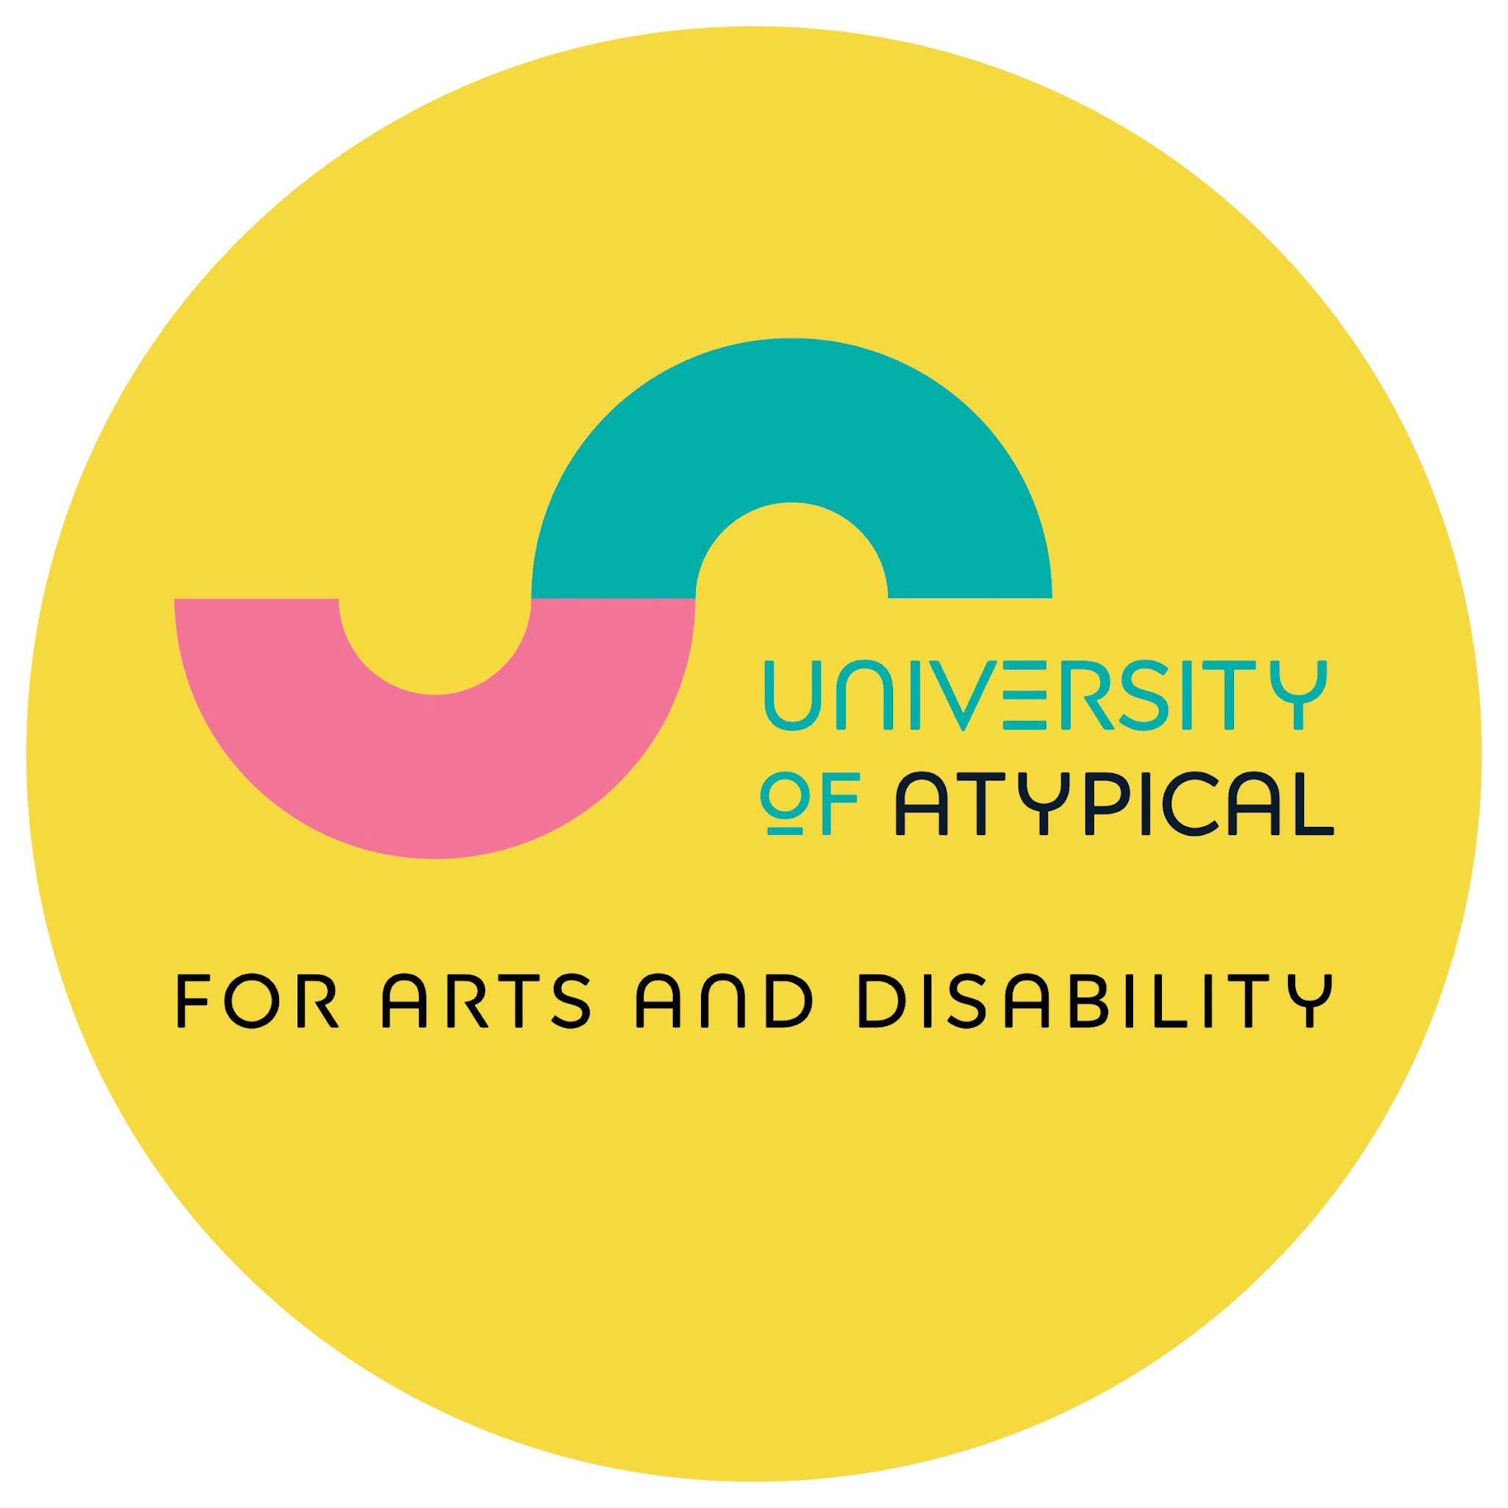

International Day of

Persons with Disabilities

Open Call
Theme: Accessibility in Fashion
Event Title: “Fashion, Identity & Inclusion:
Celebrating Disabled Creativity”

Key Dates:

Applications open: 3 September 2026
Submission deadline: 4:00 pm on Thursday 8 October 2026
Open call decision by: 16 October 2026
Artists submit advance presentation: 24 November 2026
Artists deliver presentation at event: 3 December 2026

Key Information

University of Atypical for Arts and Disability, in partnership with the Department for Communities, invites d/Deaf, disabled and neurodivergent artists to apply for an exciting opportunity to contribute to an International Day of Persons with Disabilities (IDPWD) 2026 event in Belfast.

This call is open to artists who identify as d/Deaf, disabled or neurodivergent.

Three artists will be selected to each develop and deliver a 15 minute presentation as part of the event programme.

The event will take place on Thursday 3 December 2026 at the Ulster Museum, Belfast.

Selected Artists will:

- Receive an artist commission fee of £300 for preparation of the panel presentation and creation of any new work (to be paid on confirmation of offer acceptance).
- Receive a panel participation fee of £150 (to be paid following delivery of panel presentation).
- Receive reimbursement of reasonable travel and agreed access costs. No accommodation or flights can be covered for this opportunity.

Event Information:
Venue: Belfast Room, Ulster Museum, Belfast.
Event Title: ‘Fashion, Identity & Inclusion: Celebrating Disabled Creativity’
Date: Thursday 3 December 2026
Registration & Tea and Coffee: 10:30 am - 11:00 am
Panel time: 11:00 am - 12:30 pm
Duration: 2 hours, followed by light lunch.
Access information: BSL will be provided for the panel presentation. ISL will be provided, if requested at registration time. Other access provision to be confirmed.

Theme

The theme for this opportunity is Accessibility in Fashion.

For this opportunity, we’re looking for artists who explore accessibility in relation to fashion and the fashion industry in creative, critical, and imaginative ways.

We’re interested in a broad range of perspectives and approaches to accessibility. This might include modified artistic practices, inclusivity and representation, adaptive fashion, disability and fashion, access to participation, materials and processes, or the social and cultural barriers that exist within the fashion industry.

We welcome proposals from artists working across any artform. We encourage you to interpret the theme openly and experimentally, as long as your work has a clear connection to issues relating to disability within fashion or the fashion industry.
Your response could explore areas such as:

- Fashion design: Contemporary clothing, footwear, accessories, and garment design.
- Textiles: Weaving, embroidery, knitting, crochet, quilting, dyeing, textile printing, and other fabric-based practices.
- Sculpture and installation: Three dimensional or site specific work, including soft sculpture, textile installations, and immersive environments.
- Jewellery and adornment: jewellery, millinery (hat-making), accessories, and body ornamentation.
- Photography: Fashion photography, portraiture, documentary, editorial, and experimental photographic work.
- Film: Fashion films, documentaries, animation, video art, and other moving image practices.
- Performance: Live art, dance, theatre, drag, spoken word, and performance based work exploring fashion or dress.
- Costume: Costume design and creation for theatre, film, performance, cosplay, or conceptual projects.
- Modelling: Creative modelling, fashion presentation, runway, editorial, and performance based modelling practices.
- Illustration: Fashion illustration, drawing, mixed media, comics, and visual storytelling.
- Craft: Material based practices including leatherwork, lace making, weaving, ceramics, woodwork, metalwork, and other traditional or contemporary crafts.
- Print making: Screen printing, lino printing, etching, monoprinting, relief printing, and other print-based techniques.
- Digital practice: Digital illustration, 3D design, digital fashion, animation, virtual or augmented reality, and interactive media.
- Other interpretations of the theme

Presentation of Artwork:
Alongside the presentation, artists are encouraged to display physical artwork and / or examples of the designs. We ask artists to provide work that is ready to display, including any framing or other presentation requirements needed for the work.

The Ulster Museum will provide wall space, plinths and projectors where appropriate. Digital and film based works can be presented using the museum’s projectors.

If your work needs anything specific for its installation or display, please let us know in your proposal so we can understand what’s involved.

Eligibility

- You must identify as d/Deaf, disabled or neurodivergent.
- You must be based in Northern Ireland.
- You must be aged 18 or over.
- Undergraduate students are not eligible to apply.
- Artists at any stage of their career are welcome to apply.
- All artistic work must be the artist’s own, and not infringe - directly or indirectly - the copyright of any other artist. As such, commercial generative AI may not be used for either the creation of any artistic work or for generation of ideas, and any such use will make the application invalid, or result in the withdrawal of any offer. Use of AI tools to meet the artist’s access requirements will not make the application invalid unless it is used for creation of artistic work or generation of ideas i.e. proof-reading/spell-check, speech-to-text and similar access technologies can be used.

Our Decision-Making Process

Your application will be reviewed by a selection panel.

Applications will be assessed against the following criteria:

- How your proposal responds to the theme of Accessibility in Fashion.
- The creativity and originality of your proposed presentation. How unique, interesting and considered the proposal is.
- The quality of your supporting material.
- The quality, accessibility and effectiveness of your intended presentation for an audience. Will the proposed presentation be clear, easy to follow and engaging? Is the language accessible and easy to understand, with acronyms and abbreviations avoided or explained and specialist terms clearly defined? Is there a good balance of visuals and text to help bring your ideas to life and keep the audience interested?

How to Apply

You can apply in two ways:

- Complete an application form available from the University of Atypical website, along with a monitoring form.

Or

- Email your application and supporting material to applyto@universityofatypical.org.

If you apply by email, please put “IDPWD Open Call Submission”, and your name in the title of your email, and include following:

- An artist biography and statement about your artistic practice, including what you make and why you make it (max. 400 words).
- A proposal outlining your response to the theme of Accessibility in Fashion and describing the presentation you would like to deliver. You should include the topic of your presentation and how you will engage with the theme. You should also include how you will make the presentation engaging and accessible for a wide audience e.g. how you will structure the presentation, use of visuals and display of visual work if applicable, use of language etc. (max. 500 words).
- Examples of previous work relevant to your application (maximum of 10 images, or links to film, audio or digital work where appropriate).
- An artist CV or summary of your artistic experience.
- A completed monitoring form (available on request and on the University of Atypical website).

You must self declare as d/Deaf, disabled or neurodivergent to be eligible to apply for this opportunity. University of Atypical for Arts and Disability works from the Social Model of Disability. Please state whether you self-declare as d/Deaf, disabled or neurodivergent.

If you are successful, you will be asked to sign a contract. While all participating artists will be referred to as d/Deaf, disabled or neurodivergent, no further information about the nature of your disability will be shared unless you request or agree to this.

Please ensure all application documents and supporting materials are clearly labelled with your name.

We encourage applications from artists of all cultural backgrounds, including global majority artists and artists from racially, ethnically and linguistically minoritised communities.

Access

We are committed to making this opportunity as accessible as possible.
Applications are welcome in alternative formats. If you have access requirements for the application process or require this information in another format, please contact us to discuss your needs.

Need Assistance?

If you need assistance with your application, please contact:
Email: applyto@universityofatypical.org.
Phone: 028 9023 9450

