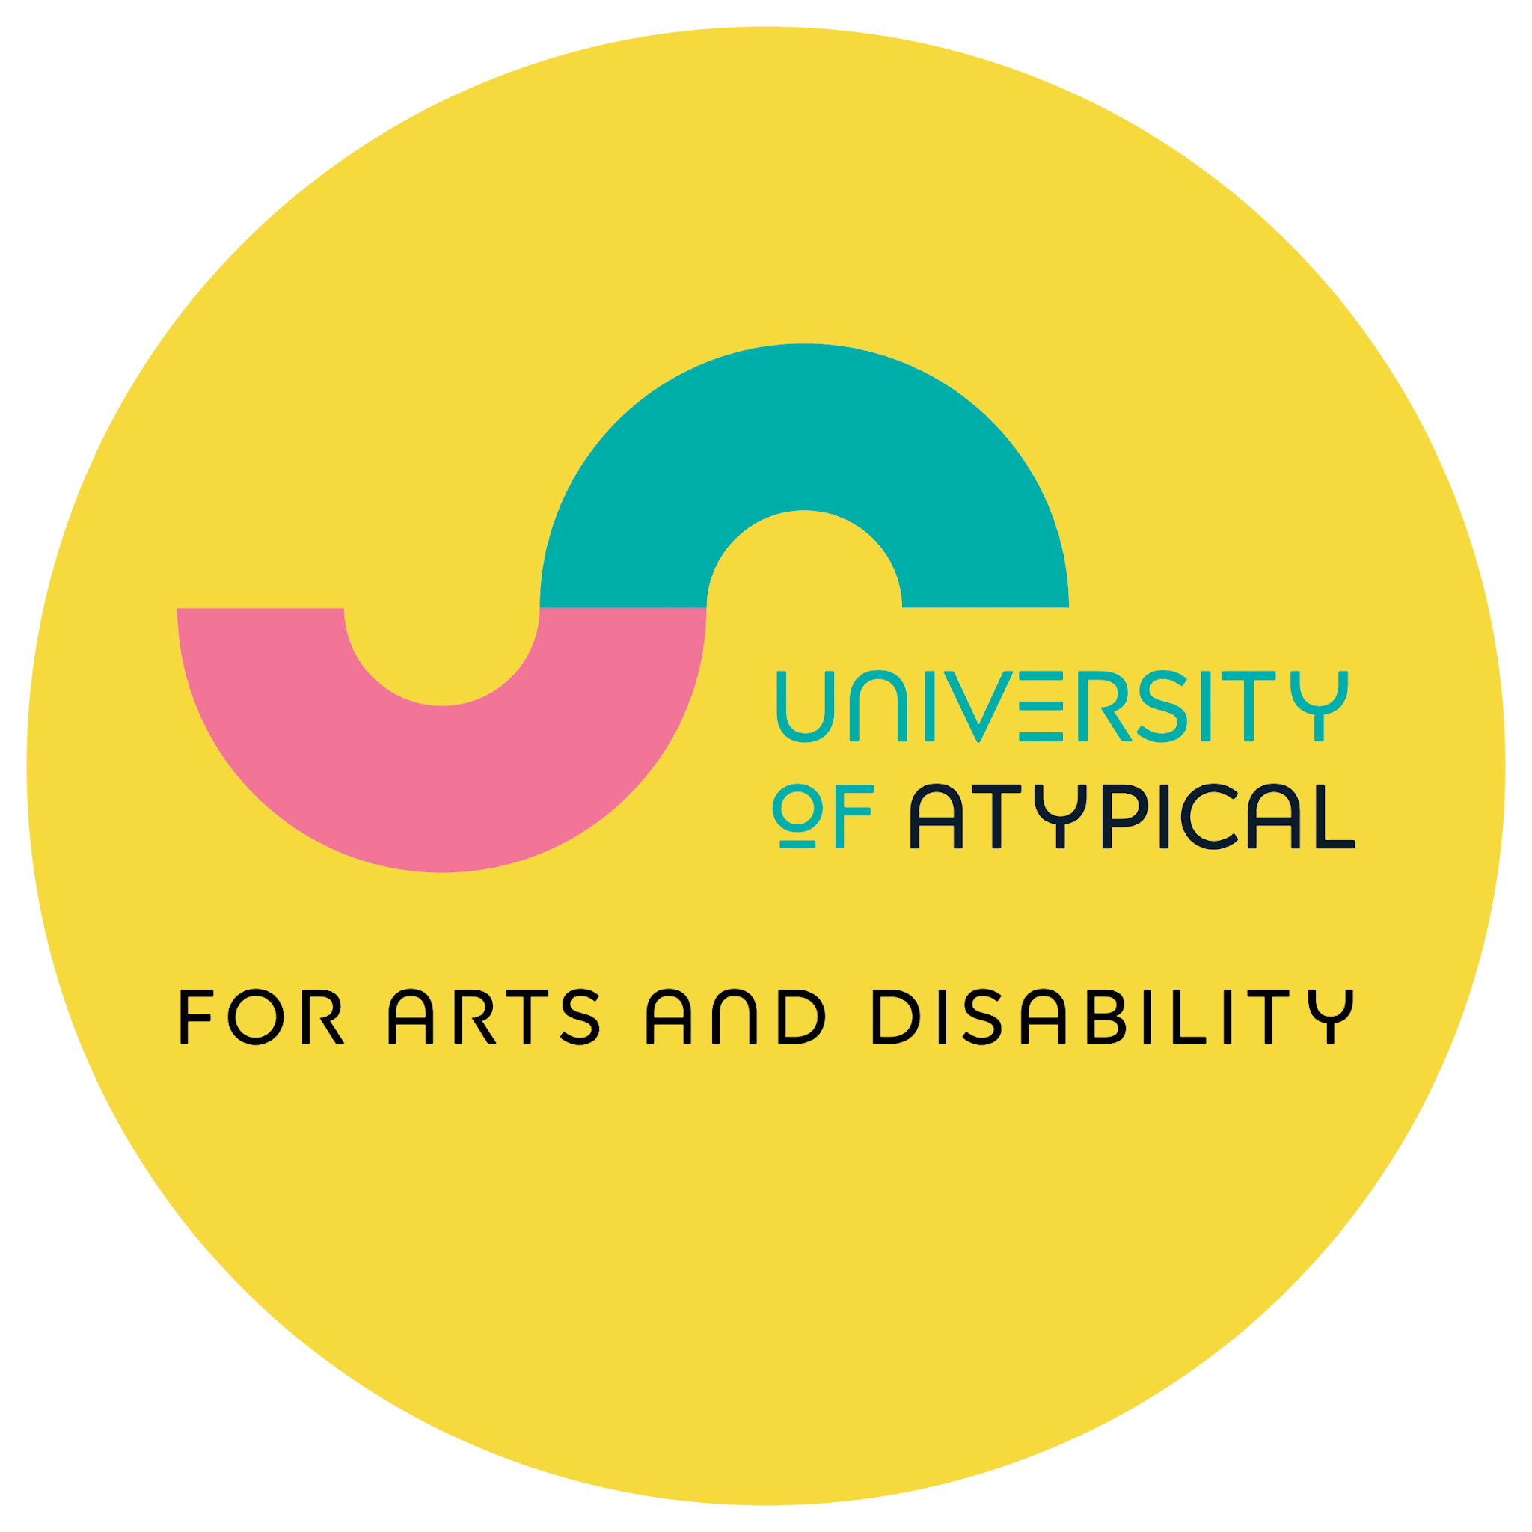

Bounce Arts Festival 2027 Proposal Form

Hello and thank you for your interest in Bounce 2027!

Bounce Arts Festival is run by University of Atypical for Arts and Disability and is Northern Ireland's only disabled-led arts festival promoting the work of D/deaf, disabled and neurodivergent professional artists and engaging audiences from across Northern Ireland and beyond.

We are inviting artists and arts organisations to get in touch with us to submit proposals for Bounce 2027 which will take place in the first week of October in Belfast. We expect events in Bounce 2027 to run from Thursday 30 September to Sunday 3 October, but this is subject to funding decisions.

While the commissioning and programming budget in any given year is limited, we work with organisations and artists in many ways to be part of Bounce. That means that some groups showcase work they have funding for already and for others we work with them to seek ways of including them in Bounce.

We look forward to hearing from you.

How to submit your proposal:
- Submission Deadline: 4:00 pm on Thursday 10 December 2026
- If you would like to discuss a proposal please contact: Neave Wright (Creative Programmes & Studio Lead) by email at neave@universityofatypical.org.
- If you have any access queries please email access@universityofatypical.org
- Or you can call us on: 028 9023 9450
- Please provide us with information on your proposal in the form below.
- When completed submit your proposal to applyto@universityofatypical.org with ‘Bounce 2027 Proposal’ in the subject line.

Your Contact Information:

Contact person(s):

Pronouns:
Group or Organisation Name (if applicable):

Address:

Email address:

Phone number:

Please advise us of any access information in relation to communicating with you:

Your Proposal Information:

- About you:
Tell us about yourself, group or organisation, and your connection to disability arts or making creative work as a disabled artist / group.

- Disabled-led:
University of Atypical for Arts and Disability is a disabled-led organisation, and so the work we programme for Bounce must be disabled-led. Please outline how your proposal is disabled-led.

- About your proposal:
Tell us about the proposal you have to be part of Bounce 2027.

4. Support you have in place:
Do you have any existing support and if so what does this involve?
(e.g. commission already funded, use of a venue in-kind, funding towards touring, travel awards etc)

5. What your proposal would benefit from as part of University of Atypical’s support?

Financial Support
(e.g., artist fees, venue, technicians/engineers, materials, travel, accommodation, etc.)

Access Support
(e.g., transportation, personal assistants, interpreters, captioning, communication)

Marketing/Promotion Support

Other (if applicable)

6. Supporting Information

- You are not required to submit supporting materials at this stage however, it may assist us in understanding your proposal if you do.

- You may include high-quality image files, sound files, or video files (or links to relevant media e.g., videos, websites, documentation).

- We can only accept the following file formats:
- Image files (JPEG, PNG)
- Sound files (MP3, WMA)
- Video files (QuickTime – AVI, MOV, MP4, WMV)
- Text files (DOC, DOCx, PDF)

7. Additional Notes - Any other details you'd like us to know?

